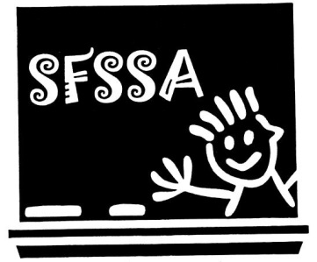

Gary French called the meeting to order at 5:03pm with 12 members are present.

Diane Neal read the secretary’s report. Val Laursen motioned to accept the minutes as read. Michelle Russo seconded. Carried.

Lori Smith read the treasurer’s report:

* Checking balance is $11,607.67
* Savings balance is $13,548.80

Lori also provided an overview of all checks written and will be inserted into the minutes binder.

Theresa Stevens motioned to accept the report. Dawn Donk seconded. Carried.

Gary reminded everyone that if they choose not to participate in the sick bank, that all forms must be submitted no later than June 15th to Diane Neal and Amy Jacuzzo in the Board Office.

If you have money left on your clothing allowance, the last day to utilize it is tomorrow, May 31st.

There is no new news on the Janus case, as we are waiting for the Supreme Court to make a ruling. However, Gary reported that we are at 97% of recommitment to the union, and we needed only be at 50% plus 1.

Congratulations were said for Mary Scalzo, who will be retiring this year after 20+ years of service to the Seneca Falls School District.

Please note that staff members must give a 90 (ninety) day written notice to the Board of Education with the intent to retire to be eligible to receive all benefits of retirement as outlined in the contract. Failure to give proper notice may result in the decline of benefits.

Rory Kelley, who was the official electoral liaison, indicated that no one from any buildings contacted him to run for any of the elected positions.

Gary called to the floor to ensure no one present was interested.

As no one was, one vote was cast for the following positions:

Diane Neal, Secretary. Carried.

Lori Smith, Treasurer. Carried.

Barbara Kelley, Vice President. Carried.

Gary French, President. Carried.

Gary mentioned that there is language in the constitution that will be evaluated and re-vamped if needed, including language that prevents anyone from holding the position of President without having held the office of another elected position. When the changes are made they will be presented for the body and voted on.

Michelle Russo motioned to adjourn the meeting. Seconded by Val Laursen. Carried.